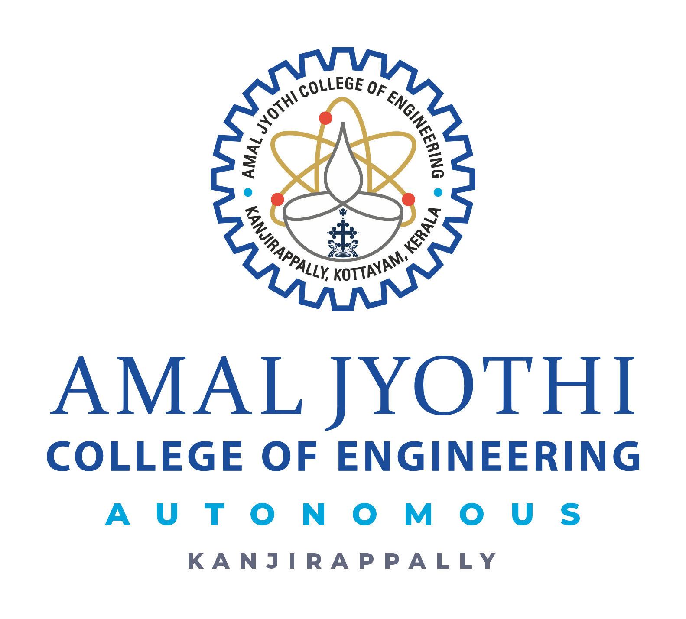
NUTRIROOT
23INMCA310 - Mini Project 1

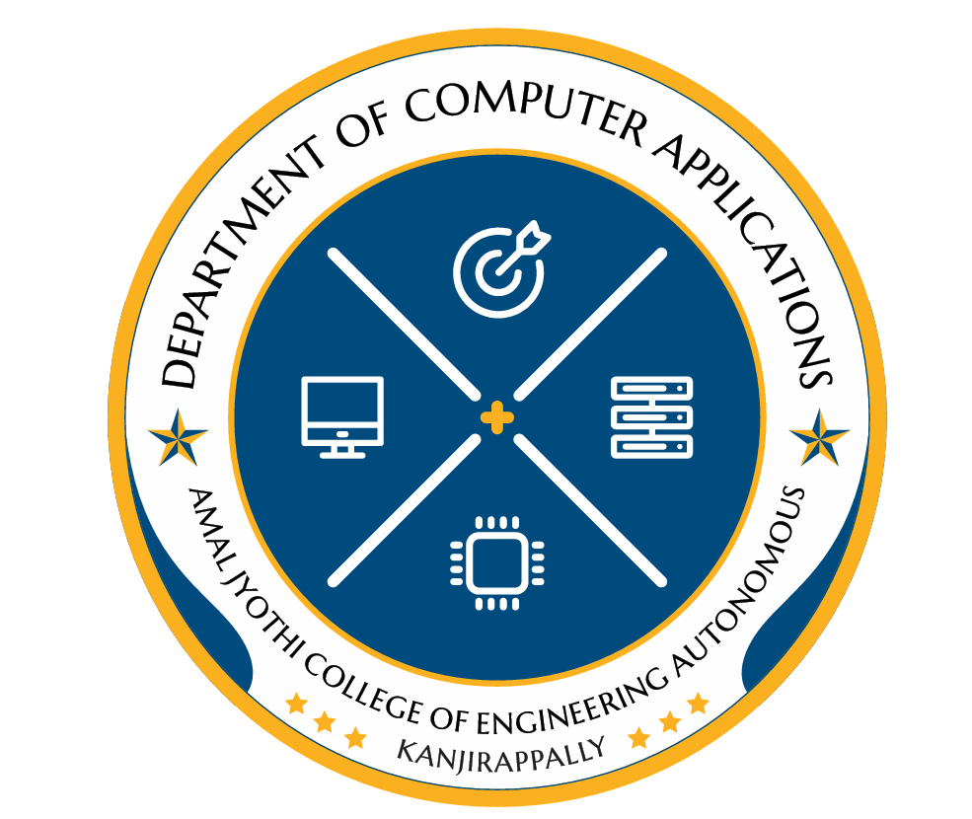

ALPHONSA AUGUESTINE
AJC23MCA-I016
INTMCA2023-28 S6
Roll No: 15

Scrum Master
Amal K Jose
Assistant Professor
Department of Computer Applications
ABSTRACT

NutriRoot: Smart Fertilizer Recommendation & IoT Soil Monitoring System

Modern agriculture requires precise nutrient management to enhance crop productivity while preserving soil health. NutriRoot is an integrated IoT-enabled smart agriculture system designed to provide real-time soil insights and accurate fertilizer recommendations through a web-based decision-support platform. The system captures key soil and environmental parameters—including Nitrogen (N), Phosphorus (P), Potassium (K), soil pH, moisture level, temperature, and the selected crop type—using IoT-based soil sensing devices. These measurements enable intelligent and data-driven fertilizer optimization.
The IoT hardware deployed in the field continuously collects soil metrics and transmits the data to the cloud through an embedded microcontroller system. The NutriRoot web application—developed using HTML, CSS, and JavaScript on the frontend and Python on the backend—features a Real-Time Dashboard, Fertilizer Recommendation Page, Crop Suggestion Page, Historical Data Graphs, and an Alert System that notifies users of abnormal soil conditions. User authentication and profile management ensure secure, personalized access.
All collected data is efficiently stored and managed in a MySQL database, while IoT communication utilizes HTTP-based APIs for seamless data transfer. Users can also generate and download customized PDF reports summarizing soil status and fertilizer requirements.
By integrating IoT sensing technology, intelligent backend processing, and modern web frameworks, NutriRoot advances precision agriculture, enhances decision-making, reduces fertilizer wastage, and empowers farmers with real-time, actionable insights for sustainable crop management.

